**Web Tool Notes**

**Login**

* Once logged into the Web Tool, I would still really like to start making selections at the provincial level each time so there is less navigating to do. I think it’s great that you can type in the name of the province you are looking for in the search bar above but I don’t want to have to do that every time either. There must be a way to make the location start at Canada at least. This was brought up/address in a past call however Charles is still working on the solution. It consists of shortcuts customizable to each user (user favorites). So next to the search bar you can quickly click and go to the desired page. To come!

**Map**

* I would like to see a standard number of characters displayed for the labelling of points depending on what you are viewing (ex. sector vs subsector vs site/station level). I know I can change this to what I want using the map helper, and I think it’s great the option is there, but can we come up with a default setting? I propose 5 characters for Area ex. NS-01, 9 for Sector level ex. NS-01-010, 14 for subsector level ex NS-01-010-001, 4 for sample level ex. 0030. Charles will work on something for each user to customize (user preference) how they would like to see the map. The users can change that once and the system will remember the preferences selected and this way not forcing all users to have the same character length.
* At subsector level, can we label with station numbers only? Make the display default to 4 characters so you don’t have to go into the map helper to change right away. Map Helper is a really nice feature to be able to customise what the user wants to see but I’d prefer to not have to use it to change my view every time. Charles is not sure how this can work because of the Google earth interface , he will find suggestions and we can talk about it at the meeting in Moncton seeing as we will have everyone here and on videoconference. He suggested that we may be able here again to use a user preference option.
* Can we pick different markers/labels for the WQ sites? Could we have a map display something like this maybe: See above comment

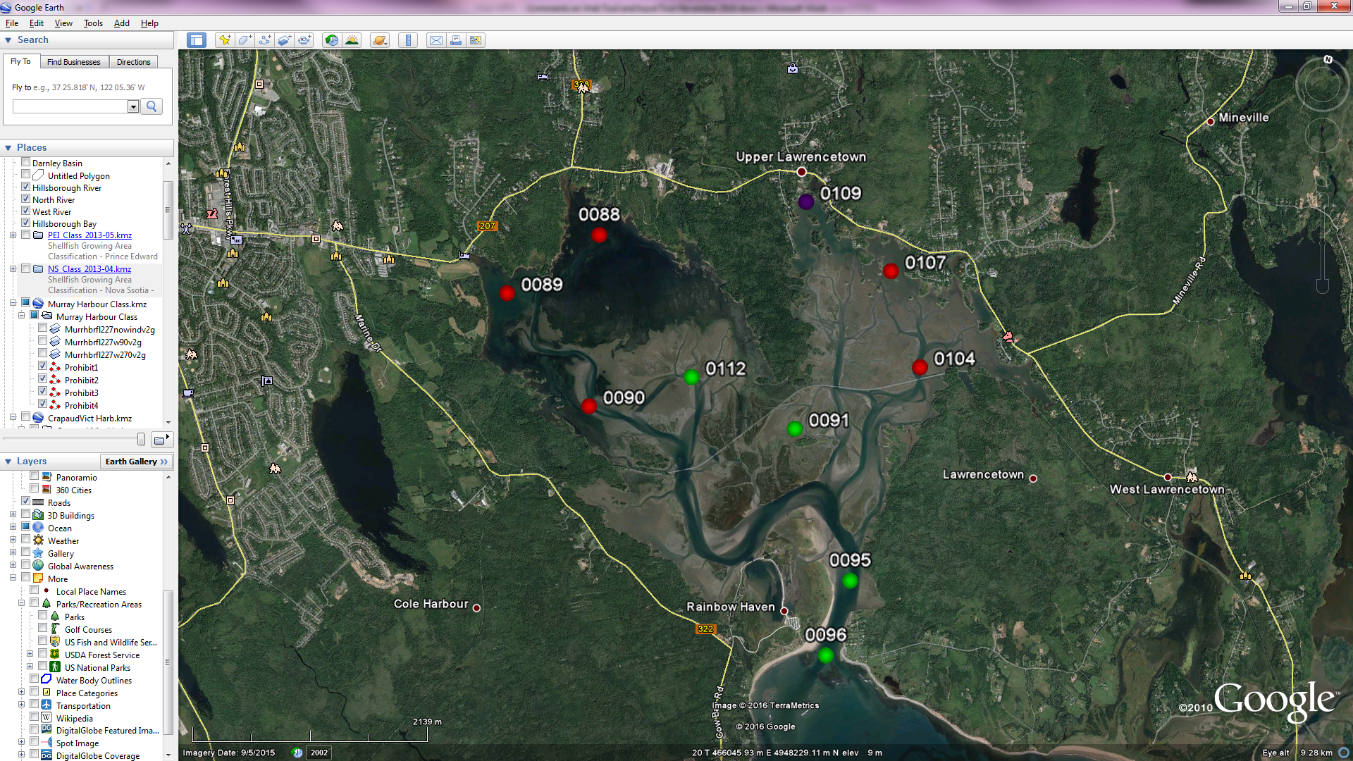

* I really like the idea of the colour coding depending on the stats at the station, very useful.
* Is it possible to get rid of the arrow buttons which make the map larger or smaller and just be able to drag the map screen with the mouse instead? Or even just move the arrow buttons to the map so they aren’t grouped with the other buttons? Or delete them since you have the option in the map helper? These extra arrows are needed for tablet or touch screen users. He will look into this more.

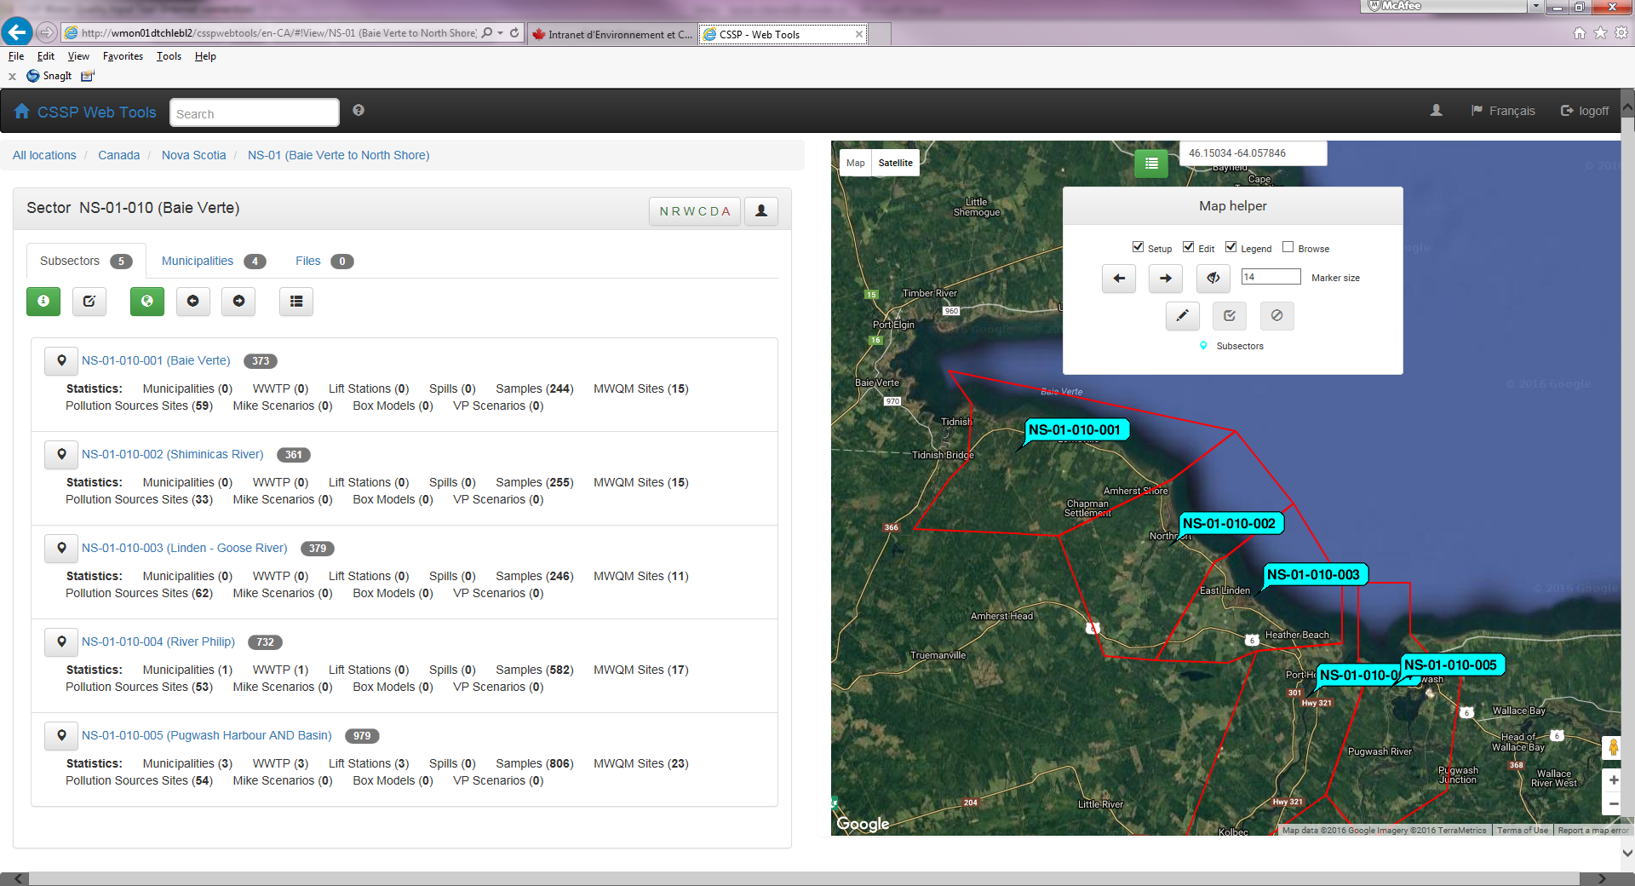

**Provincial Level**

* Can we have a separate tab for datasheets waiting for approval? This is a good idea and will move the approval of data sheets out of the ‘sampling plan’ tab. To come.

**Subsector Level**

* **MWQM sites tab**, if you the edit station information, what base file is it modifying? A master station list? YES, the webtool now is the interface for your database just like ASGAD was before. What if you de-activate a station, will that be reflected in the config/sample plan? Any sampling plans created prior to any changes, will need to be edited as needed. If you de-activate a station in webtools after you created you sampling plan, that station would still be in your sampling plan until you remove it. If you add a site, same question. Same answer.
* At the subsector level, where the stations are listed, can we change the display of stats? It is hard to read.

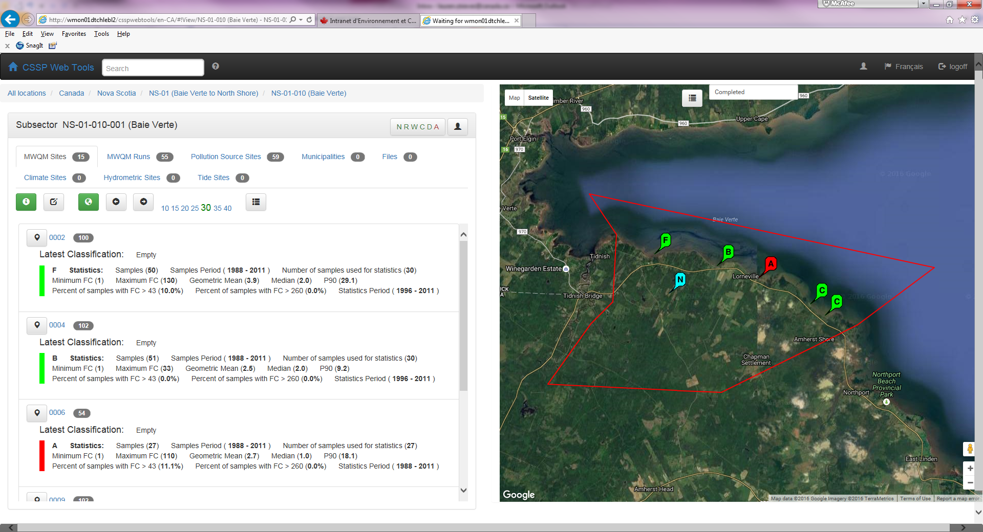

Could the information be organized in a format similar to table 1 we use in our reports but with the ability to be able to click on the site number to get a listing of the data (temp, salinity, MPN) for that particular site (which is already available)? He can change the way it’s displayed to look more like table 1. Of course we’d also want additional information to display such as %>260, colours to represent stats etc. It would also be nice to have the ability to hide columns like the setup when you click on a station, with the check boxes at the top of each column. Basically a hybrid of these two tables would be great: Will work on this and come back to us.

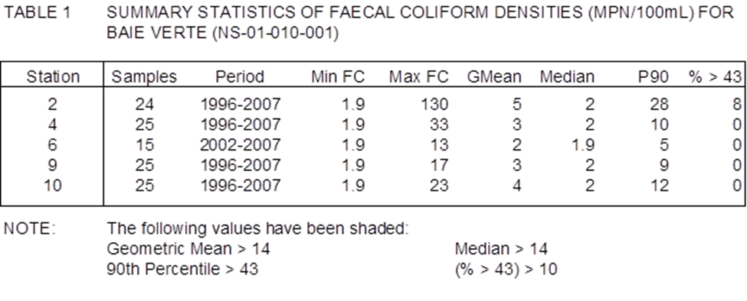

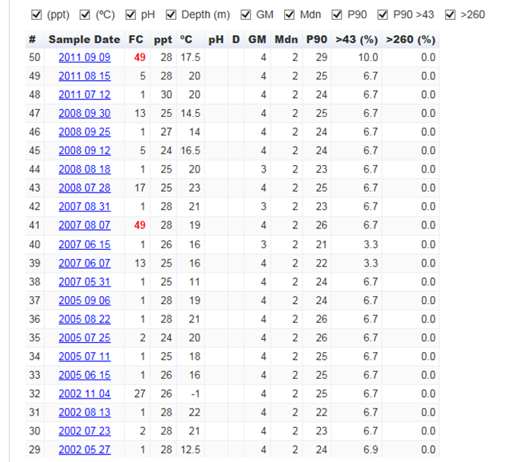

* Can we rename “samples period” to “dataset” or something along those lines? We have used ‘sampling period’ so far in our tables and reports so this could be a good time to talk about it at the Moncton meeting.
* **MWQM runs tab**, instead of just listing the run dates and stats per run, could we display the information in a table format similar to Table 2 in our reports? Do you mean when you click the information button? Are you perhaps mixing the idea of the run tab with the site tab? At the run tab level, you want to see all the data that was collected on that specific date. Could we automatically see the last 30 runs and then just like the option under the MWQM site tab, be able to select more or less runs? It would also be useful to be able to select a range of years as well in case more than 5 runs were done in a year and you want to include them in the stats. It would be great to keep the ability to click on the run date, like it is set up now, so you can view the raw data if desired. Would look something like this (but obviously much nicer): Will add this to the Moncton meeting discussion to better understand the need. Charles is working on a way for us to easily query the information without us having to either use a template or create another template. Currently we have no way of doing it quickly but once his new feature is ready, he thinks it will fill the need you described above. To discuss

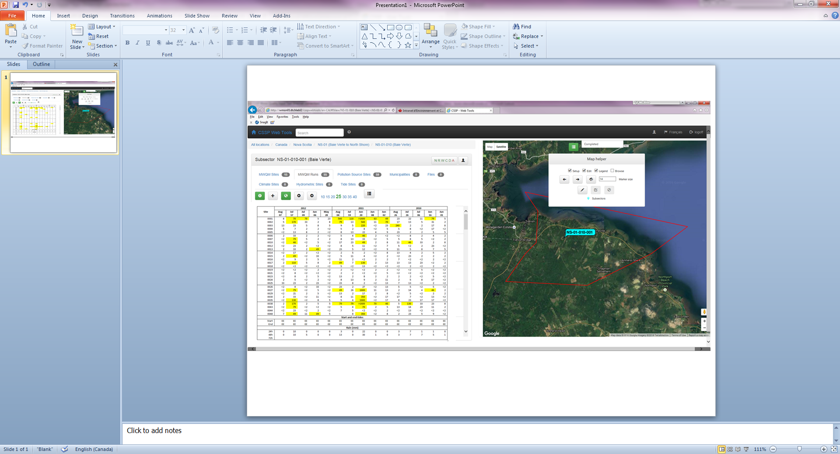

* If you add a run in what are you doing exactly? There isn’t a way to enter data in because that should be done through the input tool right? This is a way of entering a run by boycotting the input tool. For example, if we have historical data that is not in the database, we can enter it via the webtool instead of creating separate sampling plans.

**Datasheet Approval**

* The three parameters: analyze method, sample matrix, lab….. can we get rid of sample matrix? Are we ever going to sample/analyze anything other than water? Maybe I’m not understanding something. I still think that these selections should just be made in the “sample plan” creation. Nationally yes, there are other types then water. Remember, when you select it once for a subsector when doing the approval, it will remember it for the next time.

**Input Tool**

* When opening the input tool, could we rename “open sampling plan” to “select dataset” maybe? I know I was the one to propose changing the “config file” to “sample plan”, and I know that’s what you’re really opening but I think as a user the reference to the file continually changes and I think the terminology should reflect that. In the web tool when you are creating a config file, you are really setting up your sample plan for the year, when using the input tool, you’re entering data so I think it would be better to refer to it as a dataset at this point? Would it be better to refer to the file as a dataset the entire time instead? (The file is really the plan, it does not contain any data. It has the backbone for the data to be entered). Think this would make it more confusing to change it but we should bring it up at the Moncton meeting to get everyone on the same page.
* Could we rename “secret code” to password or access code (also in the sample plan creation in the web tool)? Yes, access code sounds good.
* When I enter the tides manually, then enter the WQ data, at some point the tides are getting deleted and I have to re-enter them. You should always enter tide data last, because every time you change or add a ‘Time’ then the input tool wants to warn you to recalculate the tide by re-clicking the tide button. This has to be there in order to prevent anyone from changing sampling times and forgetting to re calculate tides.
* Once data has been entered into a datasheet, you can’t go back and change the date sampled if you made an error. We need to have to ability to change the date so we don’t have to re-enter all the data. This feature in explained in the SOP, basically you select the sampling date and click F2 and a pop up box will appear to help you change the date.

**Thanks ☺**